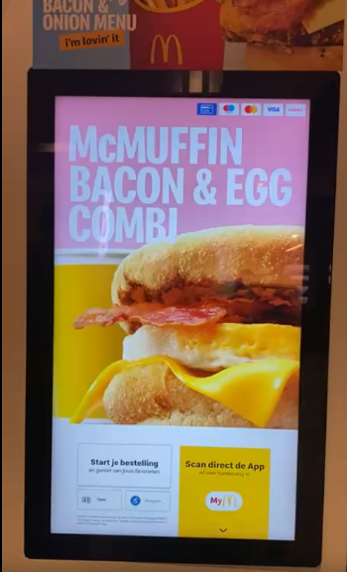
What is visible before you start placing an order?
Before starting an order, the kiosk screen shows the McDonald’s welcome screen with branding, bright images of popular menu items (like burgers, fries, and drinks), and a large “Start Order” button. The screen may also display promotional offers or featured menu items.

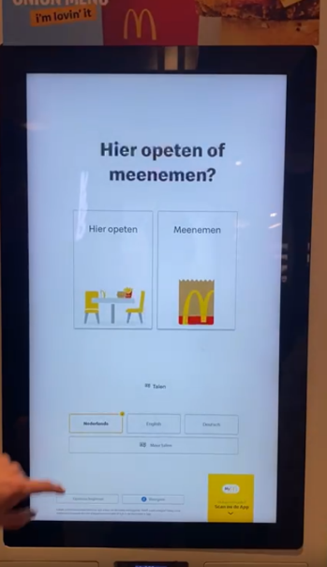
How do you start an order, and are there different options at the start?
To start an order, you tap the “Start Order” button on the touchscreen. At the beginning, you often get different options such as:
- Eat in
- Take away
Sometimes you can also select a language before continuing.

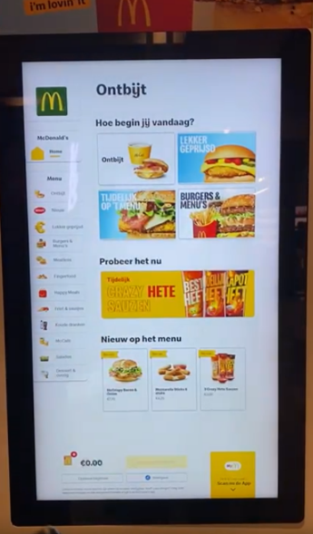
How do you add an item to your order?
You add an item by:
- Navigating through menu categories (e.g., burgers, chicken, drinks).
- Tapping on the product you want.
- Customizing the item if necessary (for example adding extra cheese or removing ingredients).
- Pressing “Add to Order”.
The item then appears in the order summary panel.
How do you remove an item from your order?
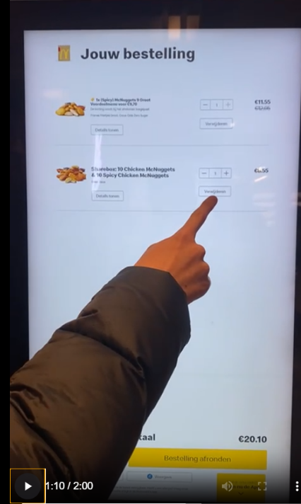
Items can be removed from the order summary panel, usually displayed on the side of the screen.
You tap the item and select remove/delete, or press a minus/trash icon to remove it.
How are the items displayed or located on the screen?
Items are displayed in large tiles with images, organized by categories at the top or side of the screen. Each tile usually shows:
- A product image
- The name of the item
- The price
The order summary appears on the right side of the screen.
How does the interaction take place? Do you only have to click or is scrolling also possible?
Interaction happens through a touchscreen:
- Tapping buttons and menu items
- Scrolling vertically or horizontally through categories
- Selecting options through touch controls
So interaction involves both tapping and scrolling.
How does the checkout process take place?
Once the order is complete:
- Press “Checkout”.
- Review the order summary.
- Choose a payment method (card or sometimes mobile payment).
- Pay directly at the kiosk.
- The kiosk prints a receipt with an order number.
- The order number appears on a pickup screen when the food is ready.
What does the design look like?
The design is simple, modern, and visually appealing. It uses:
- Large buttons
- Bright colors (red, yellow, white)
- Clear product images
- Minimal text for easy navigation
The layout is optimized for fast ordering.
What do the images and lettering look like?
The images are high-quality photos of the food, designed to look appealing.
The lettering is large, clear, and sans-serif, making it easy to read from a short distance.
How is the image quality?
The image quality is very high resolution, with sharp images and vibrant colors. The images are optimized to make food look attractive.
How big is the screen?
Most McDonald’s kiosks have a large touchscreen of about 27–32 inches.
What is the screen ratio and position?
The screen typically has a 16:9 ratio and is positioned vertically (portrait orientation) so that users can scroll through menus easily.
Where and how is the kiosk positioned in relation to its surroundings?
Kiosks are usually placed near the entrance or close to the ordering counter. They are positioned so customers see them immediately when entering the restaurant and can order before approaching the counter.
How many kiosks are present?
Most McDonald’s restaurants have 2–6 kiosks, depending on the size of the location and how busy it is.

